Inspiring All Girls to be Strong, Smart & Bold
Women’s Self-Defense Seminars !!!!
Presented by
Girl’s Inc.
in partnership with
Robert Harb - 6th Degree Black Belt & The Haverhill Shotokan Karate-Do Club
nspriting
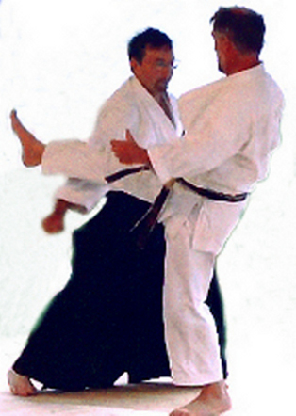
When: February 19 & 26th, March 5th & 12th
Where: Girl’s Inc., 7 Williams St., Haverhill
Time: 6:30 p.m.-7:30 p.m.
Cost: $25.00 for all 4 sessions
Register: contact rwhitson@girlsinchaverhill.org or call Girls Inc. 978-372-0771
Space is limited to the first 20 women ages 18 & older who register.

